|  |  |
| --- | --- |
| **Name:- Aryan Dilipbhai Langhanoja** | **Roll Number:- 92200133030** |
| **Subject Name and Code:-** Foundation Skills On Sensor Interfacing (01CT1103) | **Date of Experiment:- 15-12-2022** |

|  |  |
| --- | --- |
| Task:- |  |

* Interface DC motor with arduino uno development board and control the speed of DC motor using PWM.

|  |  |
| --- | --- |
| Components: |  |

* Arduino Uno R3
* DC Motor
* Jumper Wires (Male To Male)
* Laptop Or PC

|  |  |
| --- | --- |
| About the Project:- |  |

* In thisproject, we are going to control the Speed of the motor by using the PWM pin. For that we will connect one Terminal to the PWM pin and second terminal to the Ground.

|  |  |
| --- | --- |
| Schematic:- |  |

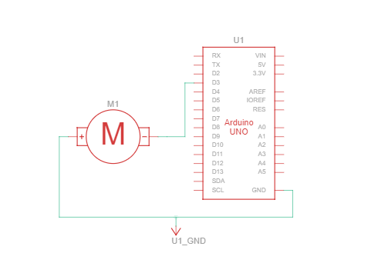

|  |  |  |
| --- | --- | --- |
| Output:- (you circuit implementation |  |  |

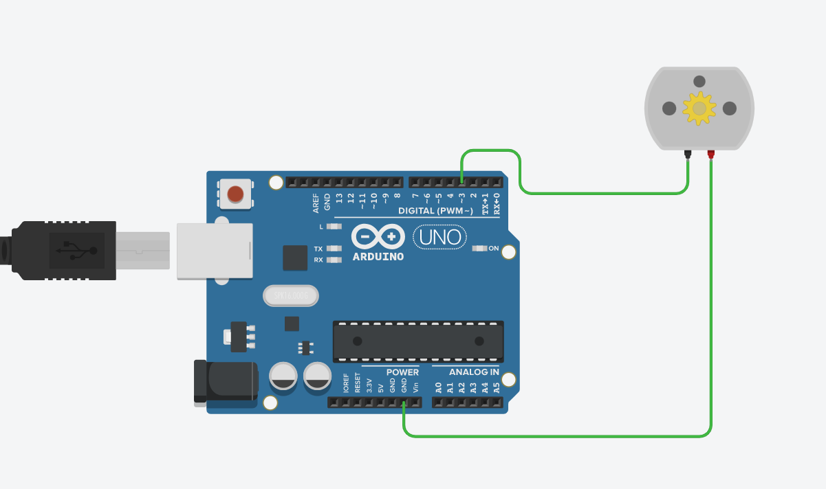

|  |  |
| --- | --- |
| Code:- |  |

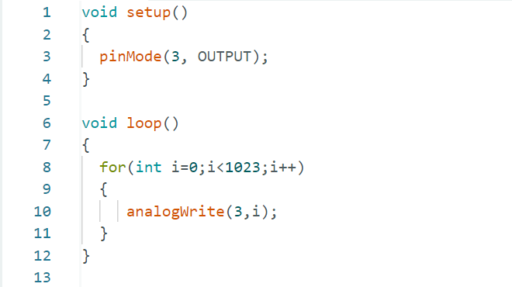

|  |  |
| --- | --- |
| Conclusion:- |  |

* In This Experiment, We Learnt That How To Control the Speed of the Motor Using PWM Pins.